TERM-1 ( 2022-23)
MATHEMATICS
NAME: ……………………….. DURATION: 3 HRS
GRADE: VIII TOTAL MARKS: 80
DATE:
SECTION-A
I.MULTIPLE CHOICE QUESTIONS: (8 X 1 =10)
1…………. Is the multiplicative identity of rational numbers?
a) 1 b) 0 c) -1 d) $\frac{1}{2}$
2. What number should be added to $\frac{7}{12}$ to get $\frac{4}{15}$ ?
a)$\frac{-9}{16}$ b)$\frac{-11}{30}$ c) $\frac{51}{60}$ d) $\frac{1}{20}$
3. Solve: 5x -7 = 2x + 8
a) 5 b) -9 c) 9 d) -5
4. The difference between two numbers is 66.The ratio of two number is 2 : 5 .What are the two
numbers?
a) 110, 44 b) 120,54 c) 140,74 d) 145,54
5. Sum of all interior angles of parallelogram is?
- ${180}^{0}$ b) ${240}^{0}$ c) ${360}^{0}$ d) ${540}^{0}$
6. A parallelogram each of whose angle measures ${90}^{0}$ is ……….?
a) rectangle b) rhombus c) kite d) trapezium
7. The square root of 12.25 is ………..?
a) 3.5 b) 2.5 c) 1.5 d) 6.5
8. What will be the value of ‘x’ in Pythagorean triplet (6, 8, x)?
a) 14 b) 2 c) 10 d) 12
Section-B
II.ANSWER THE FOLLOWING: (8X2=16)

9. Solve the following:
a) $\frac{3}{7}+ \left(\frac{-5}{7}\right)$ b) ) $\frac{-5}{12}+ \frac{7}{8}$
10. A man had Rs.90 with him. He bought $2\frac{1}{2}$ dozen eggs at Rs.22$\frac{3}{4}$ per dozen. How much
money left with him?
11. The measures of two adjacent angles of a parallelogram are in the ratio 5 : 4.Find the
measures of each of the angles of the parallelogram?
12. The length of a rectangle is 12cm and each of its diagonals measures 15cm. Find its
breadth?
13. Find the value:
a) $\frac{1}{5} ÷ \frac{3}{25}$ b) ) $\frac{18}{35}$x $\left(-3\frac{1}{8}\right)$

14. Solve the following:
a) $\frac{3x}{5}=15$ b) 8x - 4(x-3) = 2x

15. The perimeter of a rectangular swimming pool is 188m. Its length is 4m more than twice its
breadth. What are the length and the breadth of the pool?
16. Find a Pythagorean triplet one of whose member is 16?

Section-C
III. ANSWER THE FOLLOWING: (8 X 3 = 24)
17. Find ten rational numbers between the following numbers:
a) $\frac{-3}{4} and \frac{7}{6}$ b) -4 and -3
18. Simplify the following by using distributive property:
a) $\frac{2}{3}$ x$\left(\frac{7}{10}-\frac{3}{5}\right)$ b) $\frac{3}{5}$x$\left(10+\frac{35}{24}\right)$
19. Vikas’s mother is 22 years younger than Vikas’s grandmother and 27 years older than
Vikas.The sum of their ages is 121 years, Find their present ages?
20. Solve the following:
a) $\frac{7x-5}{2x}=3$ b) $\frac{2x-5}{5x+2}=\frac{3}{22}$
21. Two adjacent angles of a parallelogram are ${\left(4x-15\right)}^{0}$ and ${\left(5x-3\right)}^{0}$. Find the measure of
all angles of the parallelogram?
22. ABCD and PQRS two parallelograms. Find x and y in the given figure?

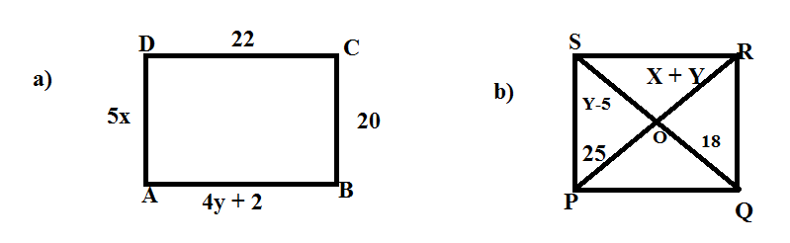
23. Find the square root by prime factorization method:
a) 14400 b) 17424
24. Construct a quadrilateral ABCD in which AB = 4.2cm, BC = 4.8cm, CD = 6.3cm, AD = 3.1cm
And BD = 6.7 cm.
Section-D
IV. ANSWER THE FOLLOWING: (8 X 4 =32)
25. Solve the following:
a) Multiply by a smallest number to get perfect square and find the square root of the
given number 1152.
b) Divide by a smallest number to get perfect square and find the square root of the
given number 36125.
26. Divide the sum of $\frac{5}{9 }$ and $\frac{-3}{7 }$ by the product of $\frac{-11}{9}$ and $\frac{-4}{7}$ ?
27. Solve the following:
a) 6x -5 = 4x + 7 b) $\frac{7x}{5} =x-4$.

28. Find the square by long division method for the following:
a) 9216 b) 26569
29. Solve the following:
a) Find the least number which must be subtracted from 4931 to get perfect square
number. Also, find the square root?
b) ) Find the least number which must be added from 8400 to get perfect square
number. Also, find the square root?
30. Construct a quadrilateral ROSE in which RO = 7 cm, OS = 3.5 cm, RE = 6 cm, RS = 7.5 cm
and OE = 7.8 cm?
31. Find the values a, b, c and d, given that ABCD is a parallelogram?
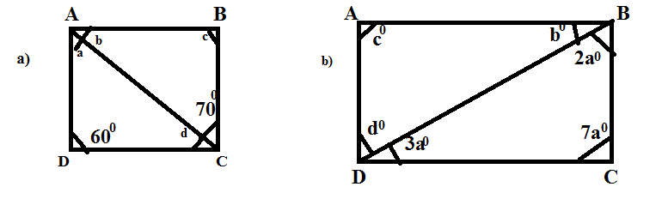

32. Simplify:
a) $\frac{-12}{15}-\left(\frac{2}{3}- \frac{4}{5}\right)$ b) $\left(\frac{5}{12} X \frac{4}{5} \right)$ ÷ $\left(-\frac{10}{30} X \frac{5}{15}\right)$

